Updated Date: 10/10/2023

# How to import data from Jira to Power BI

1. Reference:

* [Atlassian Jira data in PowerBI. This article can be read as a ‘how-to’… | by Ferdi | Medium,](https://medium.com/@ferdikoopacc/atlassian-jira-data-in-powerbi-f2baea416107#:~:text=The%20Jira%20API%20does%20not,open%20the%20Power%20Query%20Editor.)
* [How to connect Power BI to JIRA using Rest API and... (atlassian.com)](https://community.atlassian.com/t5/Marketplace-Apps-Integrations/How-to-connect-Power-BI-to-JIRA-using-Rest-API-and-without-third/qaq-p/2255960)

1. Go to [Manage API tokens for your Atlassian account | Atlassian Support](https://support.atlassian.com/atlassian-account/docs/manage-api-tokens-for-your-atlassian-account/) to generate Jira Token. The token won’t expire unless you revoke it.  
   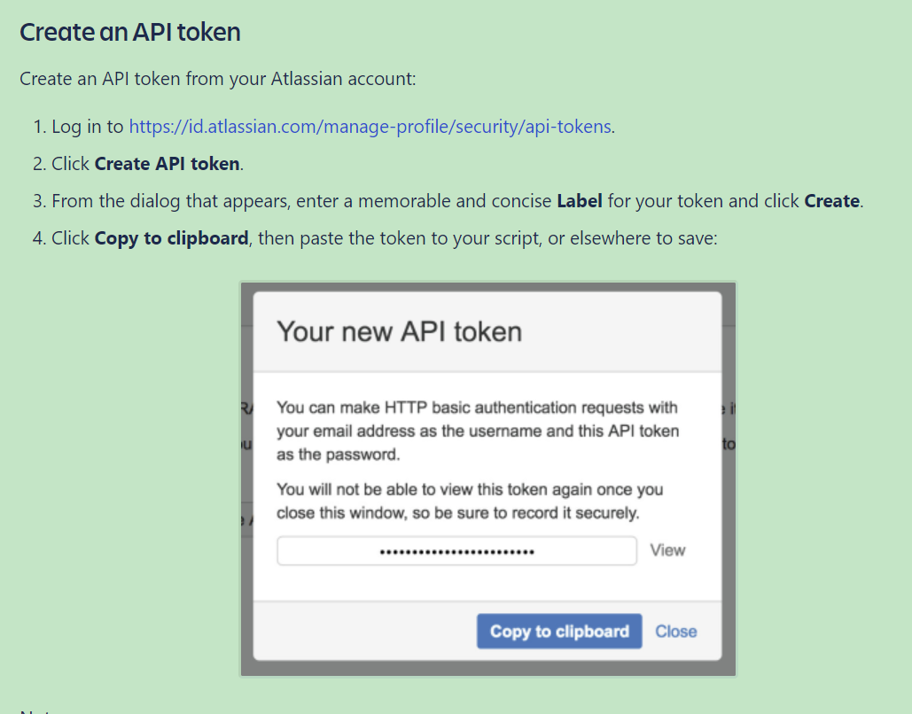
2. Convert token into Base64 format. This can be done by three ways.   
   First, [Base64 Encode and Decode - Online](https://www.base64encode.org/)   
   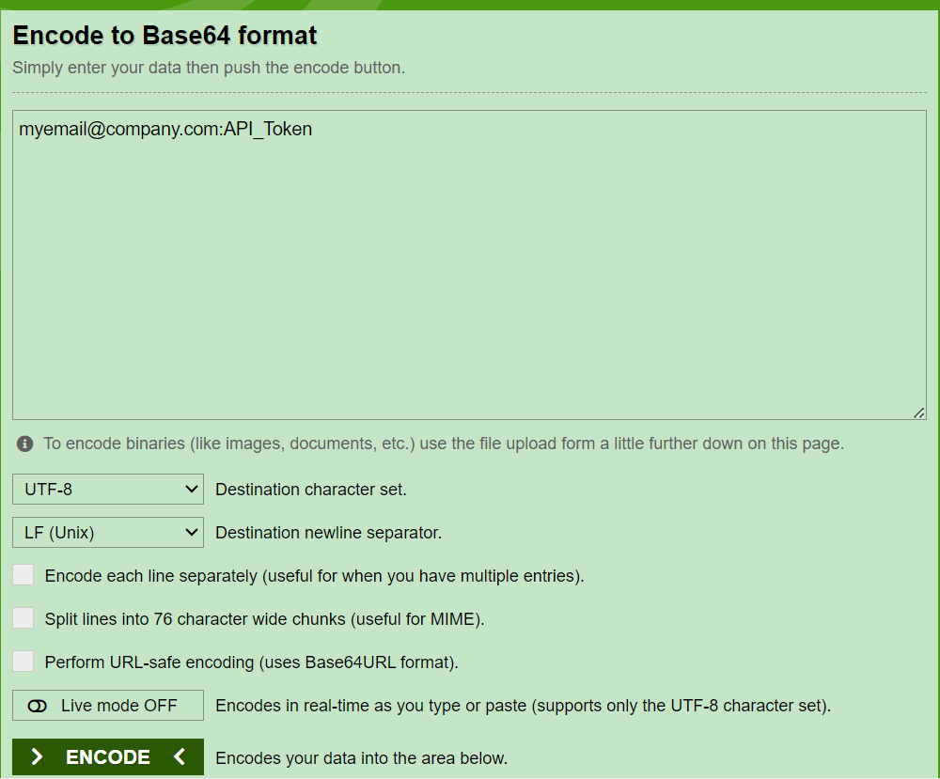  
   *<replace API_Token with your Jira token and remember to put* ***:*** *between your email and API_Token>*  
     
   Second, if you have security concern, can also refer to step 2 in this [python file](https://github.com/simonchiu902/simon-s_portfolio/blob/main/JIRA_API/jira_api_turtorial.ipynb).   
   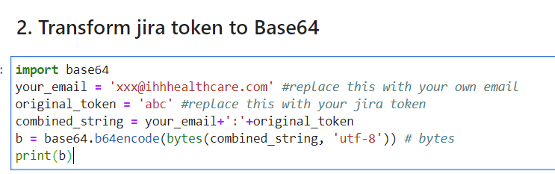  
   *<python code>*  
   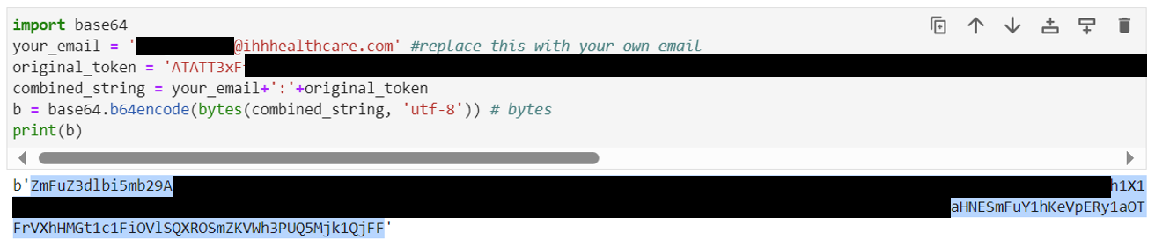*<example: the highlighted output is your Base64 token that is going to be used in the following steps>*  
     
   Third, use this [excel file](https://github.com/simonchiu902/simon-s_portfolio/blob/main/JIRA_API/Base64%20Encode.xlsm)(Reference: [Encode Base64 in Excel VBA - YouTube](https://www.youtube.com/watch?v=AU4iwjDahDY&t=194s)) 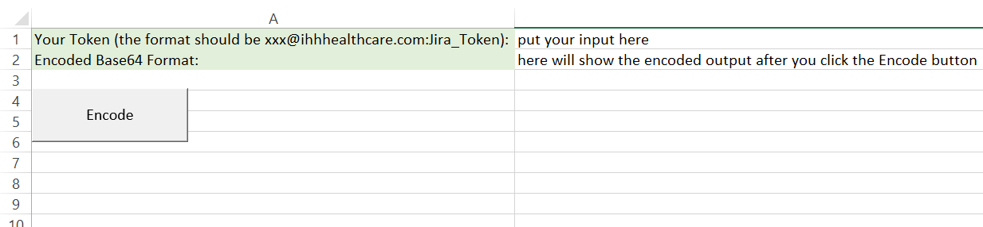  
   *Note. The converted base64 token will be used to replace Base_64_here in step 8.
3. One limitation of using Jira API to ingest data is a single API call restricts to a maximum of 100 subsequent records to be retrieved. To retrieve all records, multiple smaller requests are made using the API and Pagination. ([[JRACLOUD-67570] JIRA Cloud REST API /rest/api/latest/search?maxResults=1000 is returning only 100 results. - Create and track feature requests for Atlassian products.](https://jira.atlassian.com/browse/JRACLOUD-67570?_ga=2.101507137.1902640455.1505929864-863697658.1500488616))
4. This step will show how we can retrieve more than 100 records using JIRA API, select ‘Transform Data’ to open the Power Query Editor.  
   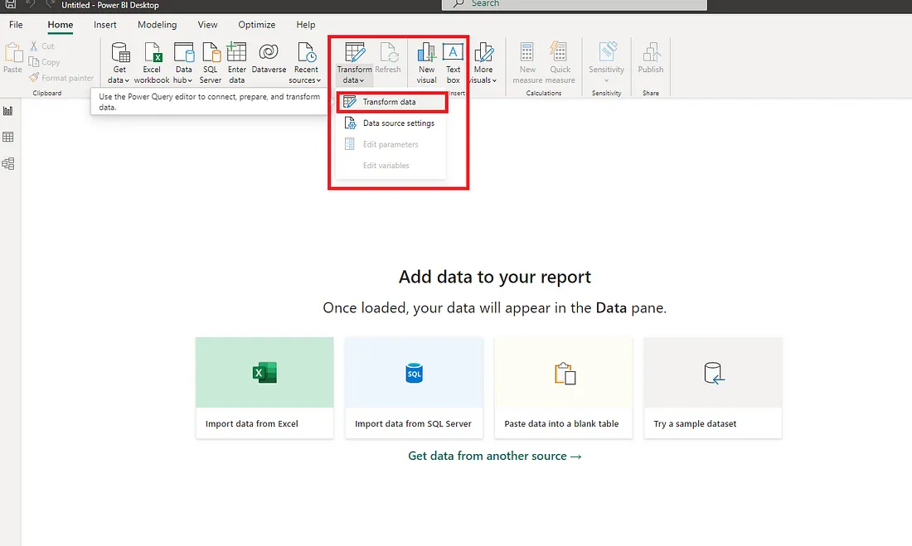
5. Create a “New Group” and name it “Jira”  
   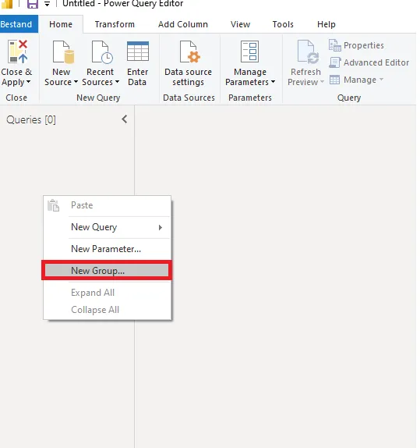
6. In the Jira group (folder) create a Blank Query and then right click it to open the query in the ‘Advanced Editor’  
   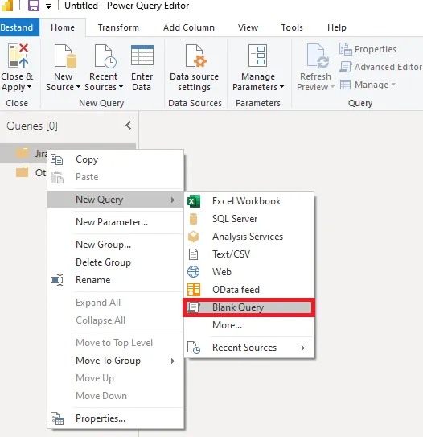
7. Replace the code with the code block below in the editor field.   
   let  
     
   FetchPage = (url as text, pageSize as number, skipRows as number) as table =>  
     
   let  
     
   //Here is where you run the code that will return a single page  
     
   contents = Web.Contents(url&"/rest/api/3/search?jql=project=IHHITREQ",[Headers=[#"Authorization" = "Basic Base64_here"], Query = [maxResults= Text.From(pageSize), startAt = Text.From(skipRows)]]),  
     
   json = Json.Document(contents),  
     
   Value = json[issues],  
     
   table = Table.FromList(Value, Splitter.SplitByNothing(), null, null, ExtraValues.Error)  
     
   in  
     
   table meta [skipRows = skipRows + pageSize, total = 500]  
     
   in  
     
   FetchPage  
     
     
     
     
   First, replace IHHITREQ (E.g. Or your JIRA Project) with your project key. Your key can be found in your Jira website.  
   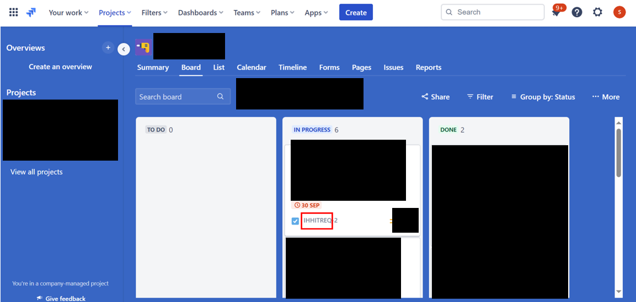  
   Second, replace the ‘Base64_here’ with the base64 encoded string that was generated earlier. Remember to keep the ‘Basic ’ in front of it. (Make sure you keep a space after Basic)  
     
   If you want to further include more projects and filter by issue created date, you can modify url&"/rest/api/3/search?jql=project=IHHITREQ" to be   
   url&"/rest/api/3/search?jql=project in ('IHHITREQ','SG360','IHHVDO') AND created >= '2023-09-11' AND created <= '2023-10-03'"  
   (Reference: [How to query through the date range by JIRA REST API? - Stack Overflow](https://stackoverflow.com/questions/36450428/how-to-query-through-the-date-range-by-jira-rest-api))  
     
   When done rename the query to ‘FetchPage’.
8. Create a second query and rename it to ‘FetchPages’ and copy the following code into it  
   let  
     
   FetchPages = (url as text, pageSize as number) =>  
     
   let  
     
   Source = GenerateByPage(  
     
   (previous) =>  
     
   let  
     
   skipRows = if previous = null then 0 else Value.Metadata(previous)[skipRows],  
     
   totalItems = if previous = null then 0 else Value.Metadata(previous)[total],  
     
   table = if previous = null or Table.RowCount(previous) = pageSize then  
     
   FetchPage(url, pageSize, skipRows)  
     
   else null  
     
   in table,  
     
      
     
   type table [Column1])  
     
   in  
     
   Source  
     
   in  
     
   FetchPages
9. If an error pops up with the following message ignore it — this will be solved after creating (and renaming) the third query:  
   *Expression.Error: The name ‘GenerateByPage’ wasn’t recognized. Make sure it’s spelled correctly.*  
   Create a third Query and rename it to: ‘GenerateByPage’ and copy the following code block into it.  
     
   (getNextPage as function, optional tableType as type) as table =>  
     
   let  
     
   listOfPages = List.Generate(  
     
   () => getNextPage(null),  
     
   (lastPage) => lastPage <> null,  
     
   (lastPage) => getNextPage(lastPage)  
     
   ),  
     
   tableOfPages = Table.FromList(listOfPages, Splitter.SplitByNothing(), {"Column1"}),  
     
   firstRow = tableOfPages{0}?,  
     
   keys = if tableType = null then Table.ColumnNames(firstRow[Column1])  
     
   else Record.FieldNames(Type.RecordFields(Type.TableRow(tableType))),  
     
   appliedType = if tableType = null then Value.Type(firstRow[Column1]) else tableType  
     
   in  
     
   if tableType = null and firstRow = null then  
     
   Table.FromRows({})  
     
   else  
     
   Value.ReplaceType(Table.ExpandTableColumn(tableOfPages, "Column1", keys), appliedType)
10. The results so far should be:

* First query with the name FetchPage;
* Second query with the name FetchPages;
* Third query with the name GenerateByPage.

1. The final step before the data can be used in PowerBI is to invoke the ‘FetchPage’ query. For our company, replace url with ‘https://ihhgroupdata.atlassian.net/’ and remain pageSize = 50.  
   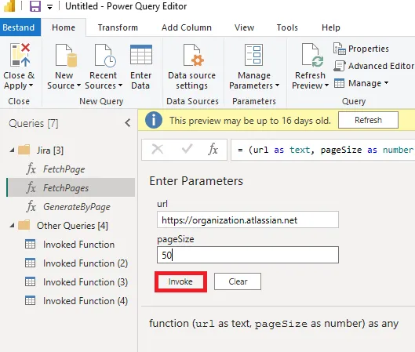
2. If this error pop up, please click “Edit Credential”.  
   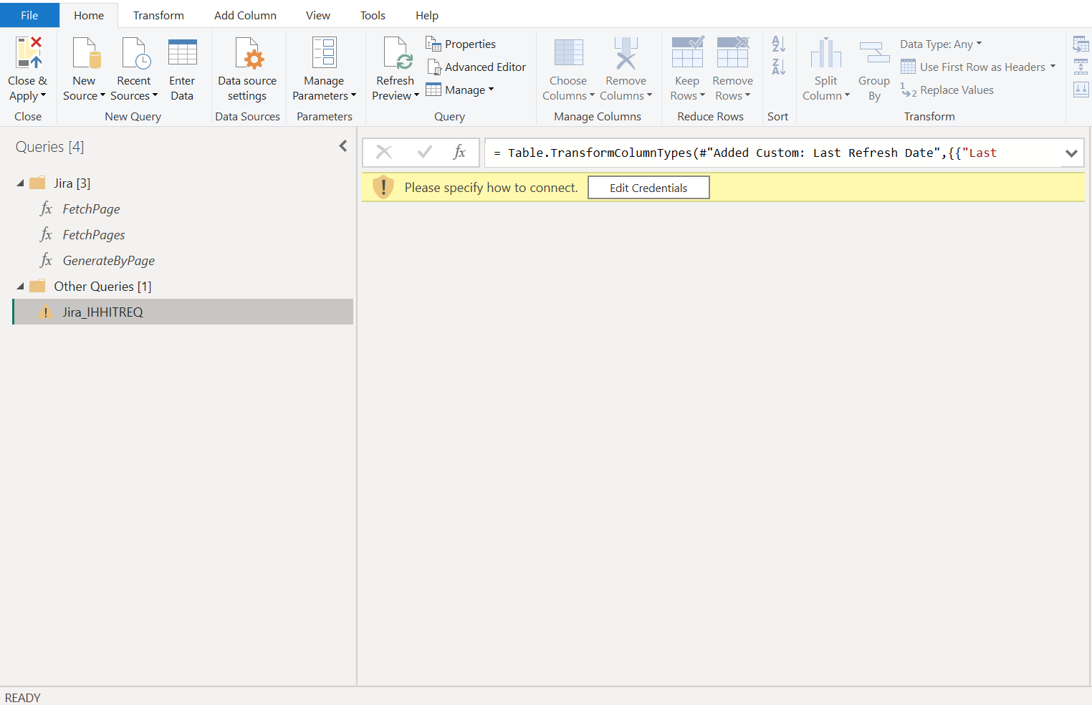  
     
     
     
     
     
     
     
     
   And then use this setting to connect.  
   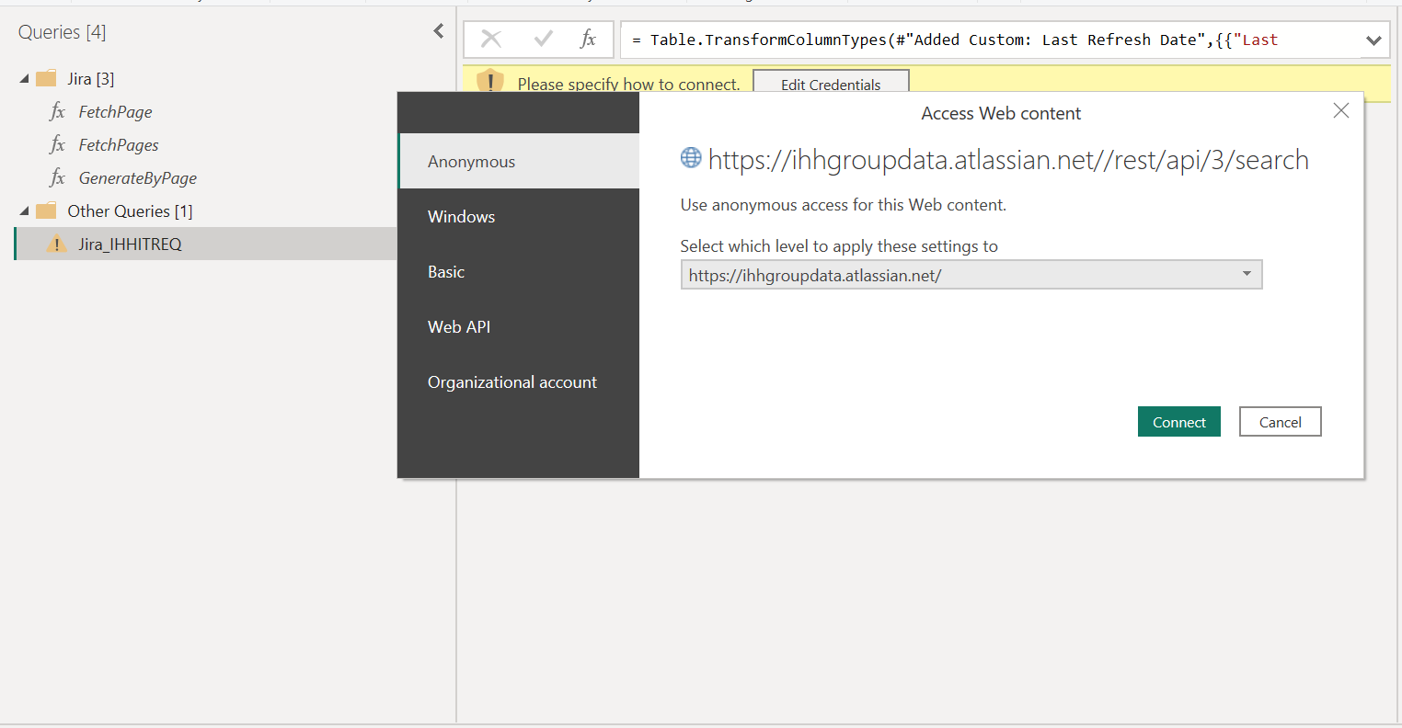
3. After invoking the query, query result should pop up. Based on your need, you can expand columns and do your own data transformation.  
   